CURRICULUM VITAE
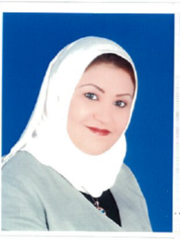

Personal Information

Name: Ghada Hameed Habib
Nationality: Bahraini
Address: House 1644, Road 2144, Block 721, Jid Ali, Bahrain
Contact Number: (+973) 39699089, (+973) 17574992
E-mail Address: ghameed@moic.gov.bh
Date of Birth: Aug, 11 1979
Nationality: Bahraini
Marital Status: married

Career Objective

My goal is to consumer investigate, analyze, making research and develops consumer education programs and materials and responds to individual complaints by working to settle disputes among consumers and merchants.

Education
2009 I graduated from the AMA International University with a Master Degree in Finance.
2002 I graduated from Faculty of Commerce of Ain Shams University in Egypt with the honor degree of commerce

I worked as

- Accountant in Arab Banking Corporation in 2002
- Purchasing Manager Assistant in Arab Banking Corporation in 2002
- Accountant teacher in Isa Town secondary school- Ministry of
Education in 2003.
4.Senior Consumer Protection specialist in Consumer Protection Directorate in Ministry of Industry and Commerce in 2004.
5. Head of Consumption Programs Development in Consumer Protection Directorate in Ministry of Industry and Commerce since 2010 until now.

