CURRICULUM VITAE
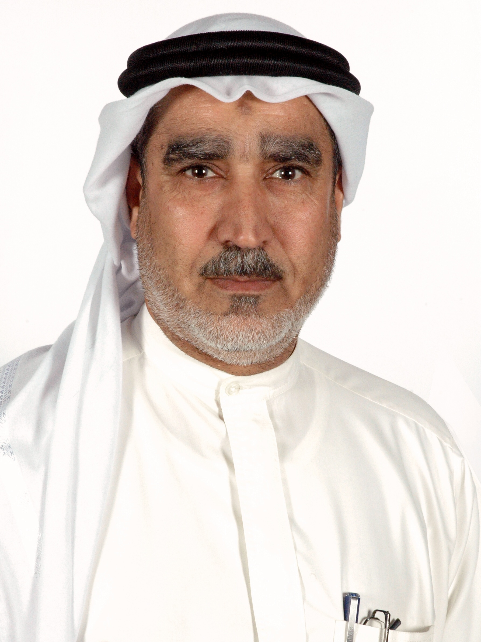

Personal Information

Name: Mr. Jaafar Ahmed Salman Ebrahim
Nationality: Bahraini
Address: House 1878, Road 3036, Block 430, Karbabad, Bahrain
Contact Number: (+973) 39189053, (+973) 17386613
E-mail Address: Jaffare@pmew.gov.bh
Date of Birth: 1st Jan 1953
Nationality: Bahraini
Marital Status: married

Career Objective

My goal is to control the physical and chemical hazards that affect the human health and environment.

Education
1998 graduated from the Bahrain University in chemistry science
May 1981 graduated from the Scottish Occupational and Environmental Health Institute – Dundee, Scotland with a diploma in occupational and environmental Health .
Nov. 1979 graduated with the associated degree in Public Health Programme from the College of Health Sciences, Bahrain.
Training and Workshops:
2002 2-weeks training course in Environmental Technology – Ministry of Environment – Singapore.

Jan 2011 2-weeks training course in Ozone Layer Protection and Global Warming Countermeasures – Japan International Cooperation Agency JICA.

Work Experience:

Has worked for more than 37 years in the fields of Public Health, Occupational Health and Environmental Protection.
- Food heath and quarantine inspector 1975 - 1979
- Occupational Health Inspector 1979 - 1982
- Senior Occupational Health Inspector 1982 - 1998
- Environmental Specialist 1998 2002
- Senior Environmental Specialist and National Ozone Officer 2002 - 2010
- Head of Pollution Control Section And National Ozone Officer 2010 - Now

Current job status

- Head of Pollution Control section, Public Commission for the Protection of Marine Resources, Environment and Wildlife.
- The National Ozone Officer for the implementation of Montreal Protocol for controlling ozone depleting substances.
- A member of the national working group to combat the mass destruction weapons , representing the General Commission for the Protection of the Marine Resources, Environment and Wildlife.

