CURRICULUM VITAE

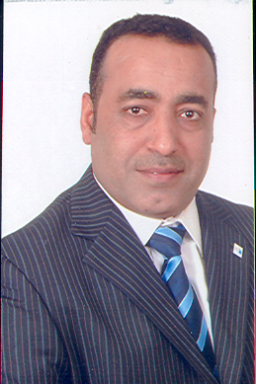

PERSONAL INFORMATION

NAME: Jaffar Mattar.

NATIONALITY: Bahraini

Address: House 1902, Road 3145, Block 231, Al Dair, Bahrain

Contact Number: (+973) 33332535, (+973) 17285725

E-mail Address: jmatar@health.gov.bh

DATE OF BIRTH : 1.1.1965
.
MARITAL STATUS: Married

CAREER OBJECTVE
________________________________________________________________

To promote and upgrade the radiation safety cultures in the healthcare services in Bahrain

EDUCATION

1998 I graduated from University of Surrey , UK with a M.Sc. Medical Physics,

1991 I graduated from King A. Aziz University , KSA, with a B. Sc. Biomedical Engineering

I worked as

- Radiation protection consultant from 2005 until now
- Biomedical engineer taking care of radiotherapy and nuclear medicine departments from 1995 till 2004.
- Lifts and escalator engineer at Schindller company, Bahrain 1993-1995
- Member of radiation protection committee GCC.

Current job status
In charge of radiation protection services in Ministry of health premises

