CURRICULUM VITAE
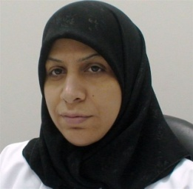

Personal Information

Name: Kubra S. Nasser Salman
Nationality: Bahraini
Address: A’Ali, Bahrain
Contact Number: (+973) 36662055.
E-mail Address: knasser@health.gov.bh
Date of Birth: Feb, 16 1973
Marital Status: married

Career Objective

My goal is to prevent, detect and control the spread of communicable diseases locally and internationally.

Education
Feb. 2003 Family Practice Residency Program ( ARAB Board)

Dec. 2002 Family Practice Residency Program ( Irish Joint Board (FPRP))
Feb. 1999 Family Practice Residency Program (FPRP)
Aug. 1992 - Jun. 1997 M.B.B.S. in Medicine & Surgery with excellent standing
Jul. 1997 - July. 1998 One year Rotating Internship
Sep1988- Jun 1991 Secondary school Certificate

I worked as

- Primary Care Physician from 2003 until now.
- Head of Immunization Group 2008.
- Country 2nd National Focal point for the International Health Regulations since 2007 until now.

Current job status

- Consultant Family Physician.
- Head of Communicable Disease Group.

