CURRICULUM VITAE
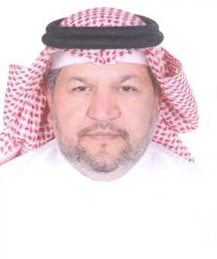

Personal Information

Name: Waleed Abdul Aziz Abdul Wahab Al Sabbagh
Nationality: Bahraini 3159 طريق 2658 مجمع 226 البسيتين
Address: House 3159, Road 2658, Block 226, AlBusaiteen
Contact Number: (+973) 39622424, (+973)17
E-mail Address: waleedalsabbagh@customs.gov.bh
wal6284@gmail.com
Date of Birth: Jan, 7 1967
Nationality: Bahraini
Marital Status: married

Career Objective

My goal is to securing and managing our borders and to simplifying trade
facilitation procedures

Education
2005 I graduated from the Arab Academy for Science and Technology and Maritime Transport with a Bachelor in Business Administration with Excellence and honor degree
1993 I graduated from Applied Science Educational in Kuwait with a Diploma in Customs Auditor.
1987 I graduated from the Secondary School General Certificate (Science Studies.).
I worked as

- Customs Officer in Custom Affairs / Ministry of Interior from 1987 until now.
- Supervisor &Customs Release Bahrain Airport from 1997 to 1999.
- Supervisor Customs clearing Bahrain Airport from 2000 to 2002.
- Head of Customs Clearing Bahrain Airport from 2003 to 2006.
- Head of Customs Clearing Bahrain Airport & Port from 2006
- Acting Head of Customs Operations in 2009
- Deputies Director of Customs Clearing Directorate on office order by
Prime Minister in 2010
- Under Secretary Director of clearing and Follow up in 2010
- Lecturer in Customs Affair Training Center since 1999.
- Member in HRD Laboratory Club in examine .Diamonds in Brussels since 2002
- GCC Focal Point to solve and facilitate goods movement since 2003
- Award with honor degree from World Customs Organization in 2005
- Regional Council Focal Point for World Customs Organization since 2007

Current job status

- Director of Clearance & follow up.
- Arabs Health members Focal point in Tobacco Taxation since 2011

